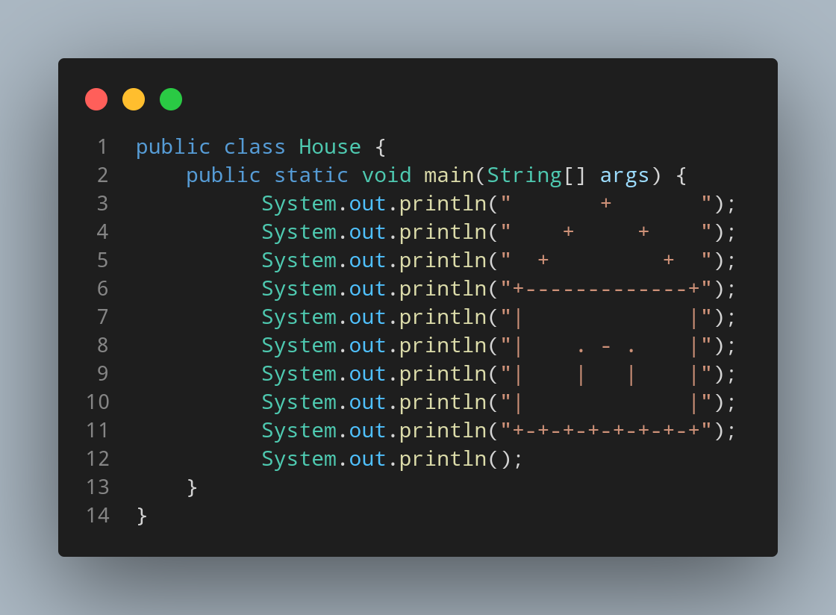

#Doc

File name House is created so we create a class name House, inside the class we created a main function. The main function only contain print function that print the spaces and symbols that are structured like House to print big House made up of symbol and space.

